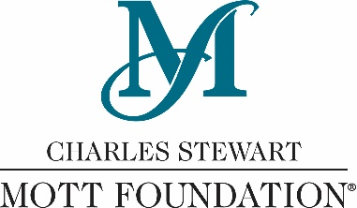
Contact:
Sarah Schuch, Communications Officer
Charles Stewart Mott Foundation
Phone: 810-766-1738
Email: sschuch@mott.org

FOR IMMEDIATE RELEASE

Mott Foundation seeks input on priorities for improving quality of life in Flint
New publication to serve as springboard for community conversations

Flint, Michigan – The Charles Stewart Mott Foundation is seeking input from members of the Flint community — residents, business owners, workers and students — regarding top priorities for improving quality of life in the city. The Foundation will use the information to help shape its local grantmaking.

“Although there are a lot of projects happening, jobs coming to the city and some good momentum in Flint, we know many residents don’t feel like things are getting better for them,” said Ridgway White, president and CEO of the Foundation. “We’re hoping to learn more from community members about their top priorities to help change that.”

As a way to get the conversation started, the Foundation created a new publication called Focus on Flint, which includes findings from surveys of 900 Flint residents, as well data gathered by local, state and national agencies. It will be sent to every mailing address in the city of Flint beginning this week.

“Especially in the wake of the water crisis, a lot of people from outside of Flint have been telling their version of Flint’s story,” said White. “We wanted to survey residents from all corners of the city to find out how they’re feeling about life in our community.”

Flint residents, along with businesses and organizations located in the city, should expect to receive Focus on Flint in the mail within the next 10 days. In the weeks and months to follow, the Mott Foundation will invite members of the community to participate in a variety of conversations about quality of life and local efforts to improve it for everyone.

“We hope residents and other community members take a look at Focus on Flint and give us their honest feedback about what they want to see in their neighborhoods and the community as a whole,” White said. “We want to make sure our local grantmaking reflects the community’s needs and concerns.”

You can learn more about Focus on Flint, share your input on priorities for the community and sign up to be notified about community conversations at focusonflint.org.

###

The Charles Stewart Mott Foundation, established in 1926 in Flint, Michigan, by an automotive pioneer, is a private philanthropy committed to supporting projects that promote a just, equitable and sustainable society. Grantmaking is focused in four programs: Civil Society, Education, Environment and Flint Area. For more information, visit www.mott.org.

